Bangladesh Rainfall Prediction

Data set -> https://www.kaggle.com/redikod/historical-rainfall-data-in-bangladesh

Index | StationIndex | Station | Year | Month | Day | Rainfall
0 | 1 | Dhaka | 1970 | 1 | 1 | 0
1 | 1 | Dhaka | 1970 | 1 | 2 | 0
2 | 1 | Dhaka | 1970 | 1 | 3 | 0
3 | 1 | Dhaka | 1970 | 1 | 4 | 0
4 | 1 | Dhaka | 1970 | 1 | 5 | 0
5 | 1 | Dhaka | 1970 | 1 | 6 | 0
6 | 1 | Dhaka | 1970 | 1 | 7 | 0
7 | 1 | Dhaka | 1970 | 1 | 8 | 0
8 | 1 | Dhaka | 1970 | 1 | 9 | 0
9 | 1 | Dhaka | 1970 | 1 | 10 | 0
10 | 1 | Dhaka | 1970 | 1 | 11 | 0
11 | 1 | Dhaka | 1970 | 1 | 12 | 0
12 | 1 | Dhaka | 1970 | 1 | 13 | 1
13 | 1 | Dhaka | 1970 | 1 | 14 | 0
14 | 1 | Dhaka | 1970 | 1 | 15 | 0
15 | 1 | Dhaka | 1970 | 1 | 16 | 0
16 | 1 | Dhaka | 1970 | 1 | 17 | 0
17 | 1 | Dhaka | 1970 | 1 | 18 | 0
18 | 1 | Dhaka | 1970 | 1 | 19 | 0
19 | 1 | Dhaka | 1970 | 1 | 20 | 0

Size of data set-> 32,54,256 ROWS and 6 COLUMNS

Training Models on 5 years of Rainfall data (from 1970 to 1975)

Plot of Rainfall each month of the year being predicted (1976) (Actual values)

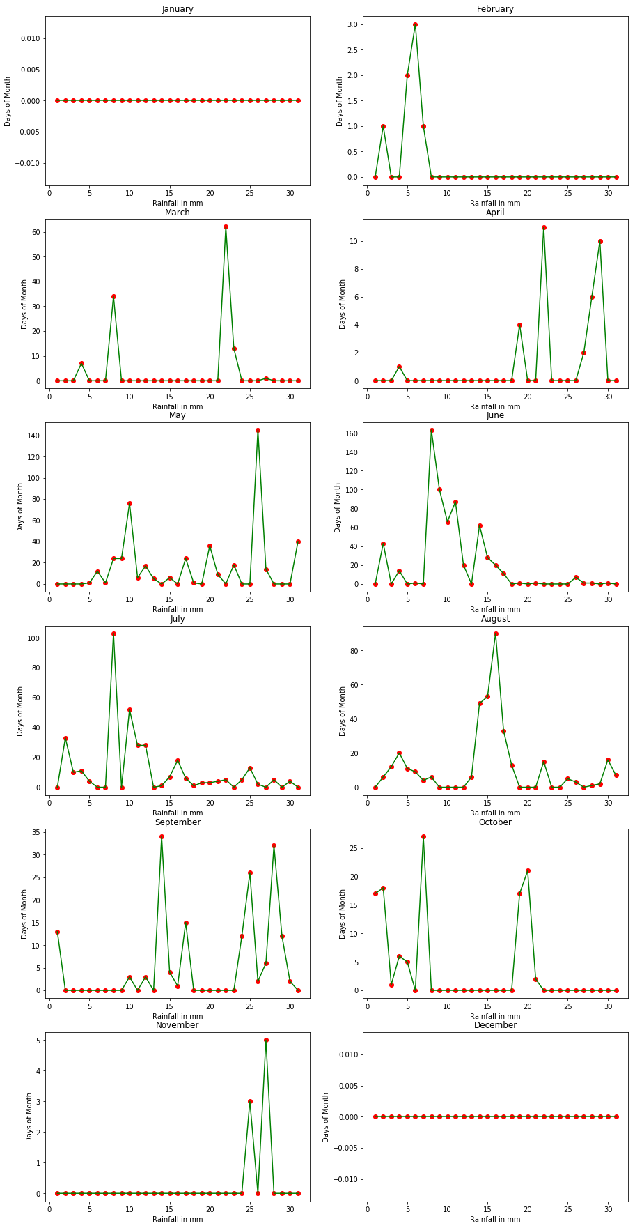

Using SVM
Predicted values

Index | Actual Rainfall | Predicted Rainfall
1892 | 1 | 1
1895 | 2 | 2
1896 | 3 | 3
1897 | 1 | 1
1925 | 7 | 7
1929 | 34 | 34
1943 | 62 | 60
1944 | 13 | 13
1948 | 1 | 1
1956 | 1 | 1
1971 | 4 | 4
1974 | 11 | 11
1979 | 2 | 2
1980 | 6 | 6
1981 | 10 | 10
1988 | 1 | 1
1989 | 12 | 12
1990 | 1 | 1
1991 | 24 | 24
1992 | 24 | 24
1993 | 76 | 75
1994 | 6 | 6
1995 | 17 | 17
1996 | 5 | 5
1998 | 6 | 6

Graph(SVM)
Blue lines are predicted values, Green lines along with Red dots is the Actual value

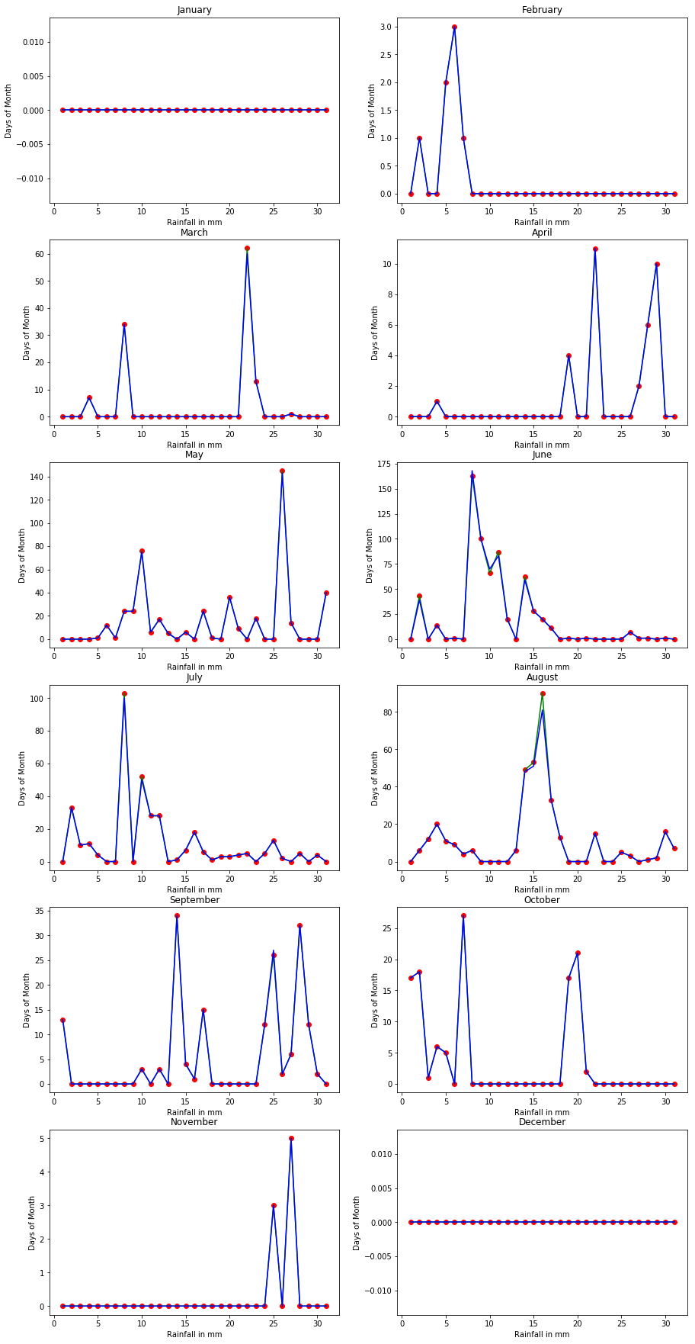
Using Support Vector Regression

Predicted values

Index | Actual Rainfall | Predicted Rainfall
1892 | 1 | 1.099172
1895 | 2 | 2.098371
1896 | 3 | 3.097573
1897 | 1 | 1.099165
1925 | 7 | 7.094390
1929 | 34 | 34.072870
1943 | 62 | 62.050538
1944 | 13 | 13.089582
1948 | 1 | 1.099138
1956 | 1 | 1.099174
1971 | 4 | 4.096761
1974 | 11 | 11.091179
1979 | 2 | 2.098344
1980 | 6 | 6.095155
1981 | 10 | 10.091966
1988 | 1 | 1.099174
1989 | 12 | 12.090407
1990 | 1 | 1.099171
1991 | 24 | 24.080842
1992 | 24 | 24.080841
1993 | 76 | 76.039403
1994 | 6 | 6.095181
1995 | 17 | 17.086415
1996 | 5 | 5.095975
1998 | 6 | 6.095176

Graph(SVR)
Blue lines are predicted values, Green lines along with Red dots is the Actual value

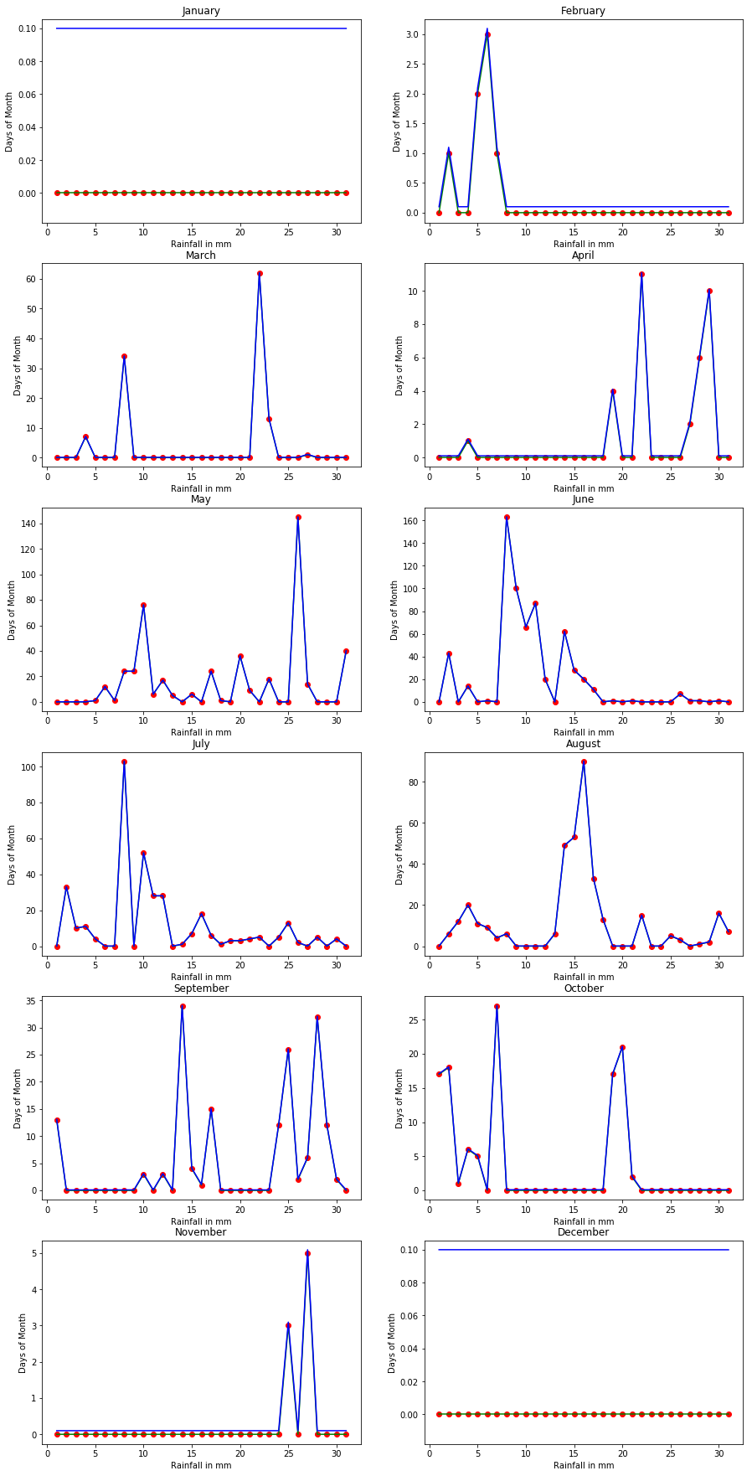

Using K-nearest neighbors algorithm
Predicted values

Index | Actual Rainfall | Predicted Rainfall
1896 | 3 | 4
1925 | 7 | 10
1929 | 34 | 34
1943 | 62 | 59
1944 | 13 | 10
1971 | 4 | 3
1974 | 11 | 10
1979 | 2 | 1
1980 | 6 | 7
1981 | 10 | 10
1989 | 12 | 10
1991 | 24 | 21
1992 | 24 | 21
1993 | 76 | 75
1994 | 6 | 4
1995 | 17 | 16
1996 | 5 | 4
1998 | 6 | 8
2000 | 24 | 25
2003 | 36 | 36
2004 | 9 | 8
2006 | 18 | 18
2009 | 145 | 143
2010 | 14 | 16
2014 | 40 | 40

Graph(K-nearest neighbors)
Blue lines are predicted values, Green lines along with Red dots is the Actual value
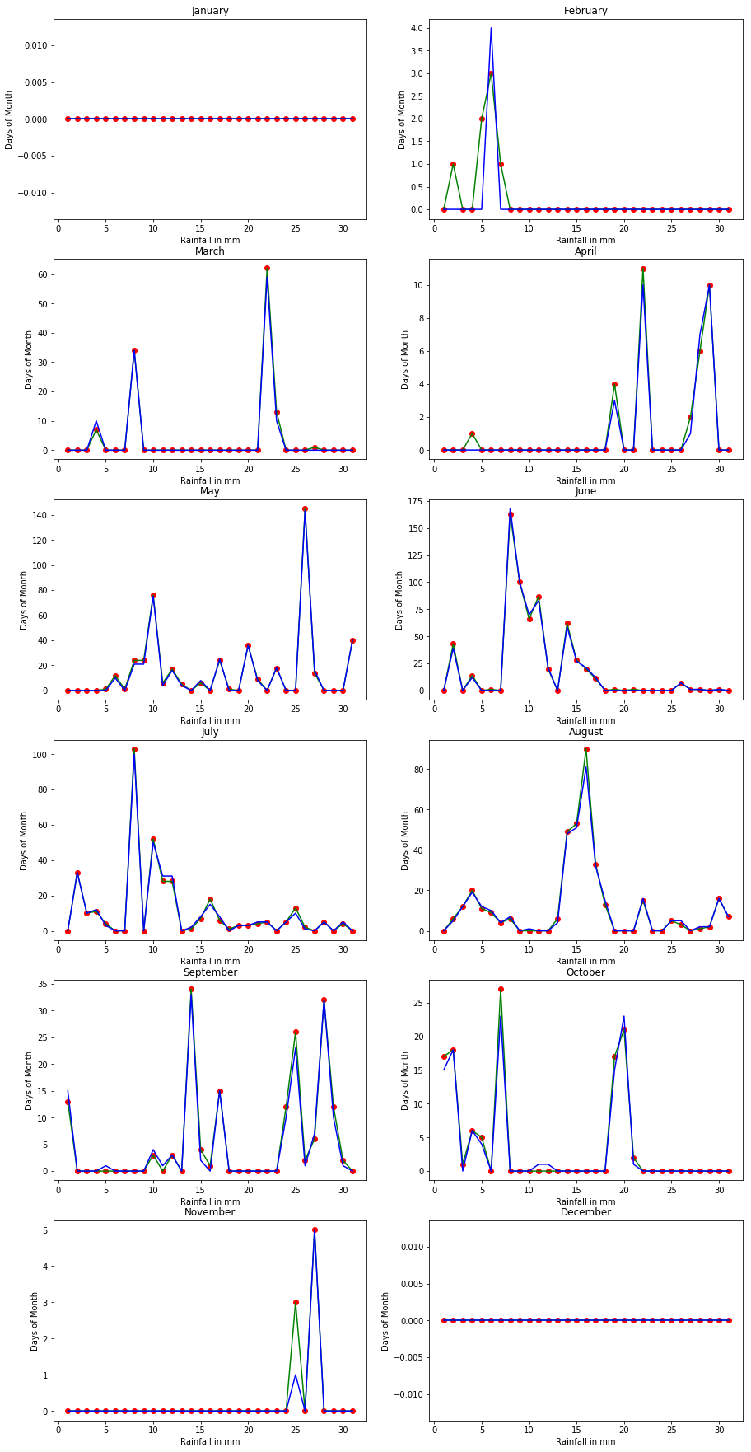
Using Neural Network (MLPClassifier)
Predicted values

Index | Actual Rainfall | Predicted Rainfall
1929 | 34 | 21
1943 | 62 | 21
1991 | 24 | 18
1992 | 24 | 18
1993 | 76 | 21
2000 | 24 | 7
2003 | 36 | 21
2009 | 145 | 83
2014 | 40 | 21
2016 | 43 | 21
2022 | 163 | 168
2023 | 100 | 83
2024 | 66 | 21
2025 | 87 | 83
2026 | 20 | 7
2028 | 62 | 21
2029 | 28 | 7
2030 | 20 | 7
2047 | 33 | 21
2053 | 103 | 83
2055 | 52 | 21
2056 | 28 | 7
2057 | 28 | 7
2061 | 18 | 7
2080 | 20 | 7

Graph (Neural Network)
Blue lines are predicted values, Green lines along with Red dots is the Actual value



